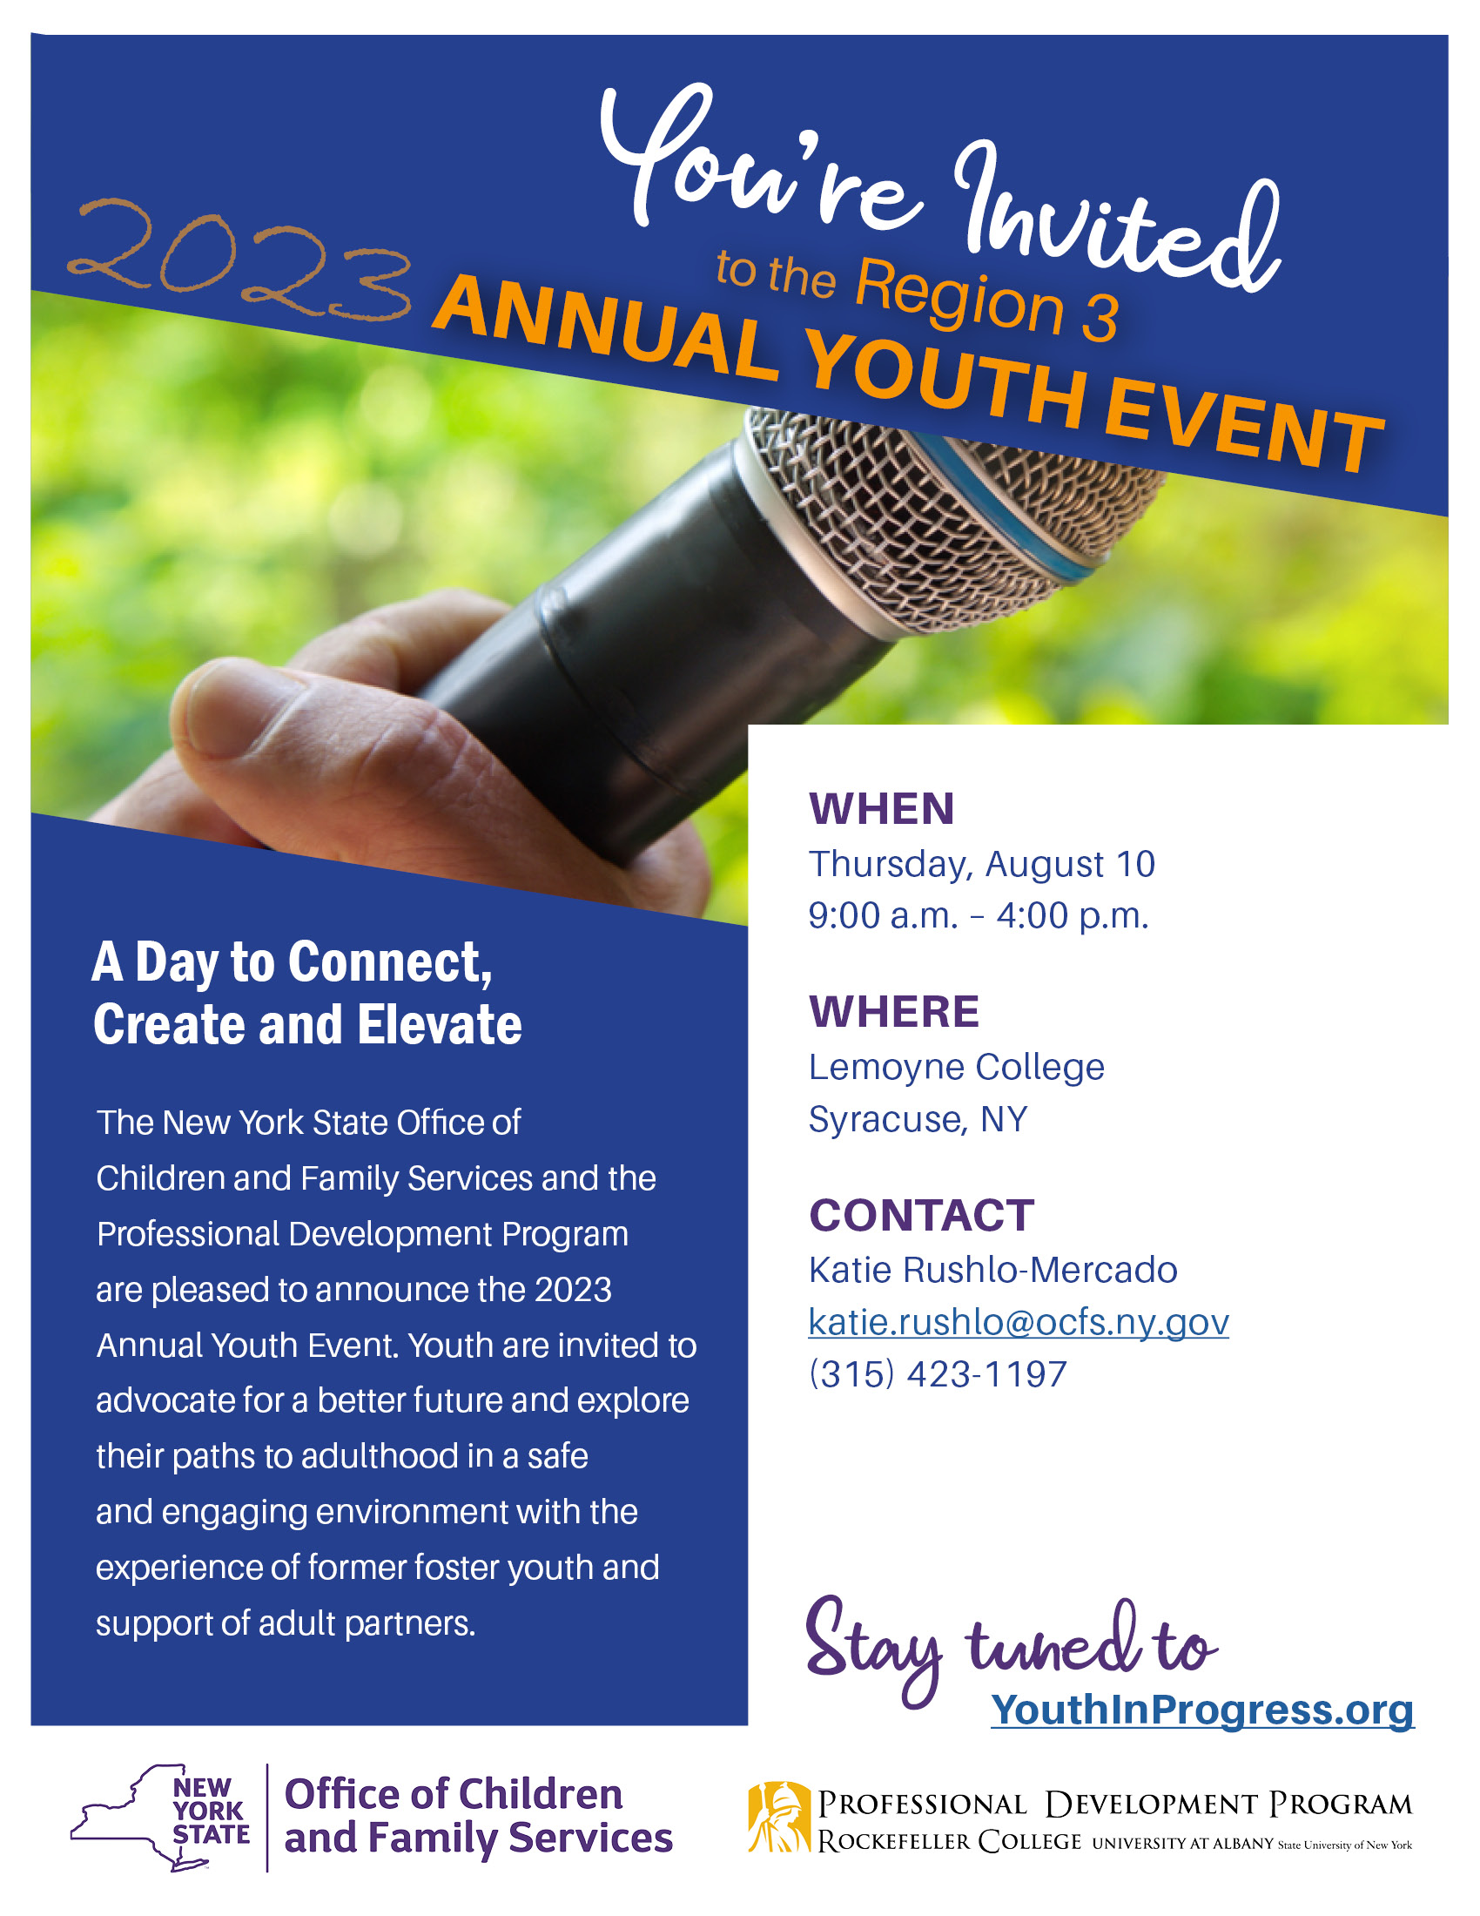

Agenda

THURSDAY, AUGUST 10, 2023

9:00 a.m. – 9:45 a.m. REGISTRATION

9:45 a.m. – 10:00 a.m. WELCOME

10:00 a.m. – 10:30 a.m. **ICE BREAKER ACTIVITY**

10:40 a.m. – 11:30 a.m. BREAK OUT ROOM ROTATION

Yellow Group: Elevate your Advocacy with Creativity

Red Group: Elevate your Attitude with Gratitude

11:35 a.m. – 12:25 p.m. BREAK OUT ROOM ROTATION

Yellow Group: Elevate your Attitude with Gratitude

Red Group: Elevate your Advocacy with Creativity

12:35 p.m. – 1:25 p.m. LUNCH / OPTIONAL TOURS

Great time to network with others!

1:30 p.m. – 1:45 p.m. SPEAK OUT INTRODUCTION & PANELIST INTRODUCTION

1:45 p.m. – 2:45 p.m. SPEAK OUT

Youth will review Speak Out rules, expectations, and invite youth to share their concerns, issues, suggestions, and success with a panel of policy makers. The intention of the Speak Out is to create meaningful change.

2:45 p.m. – 3:00 p.m. PANELIST COMMENTS

3:00 p.m. – 3:45 p.m. ICE CREAM SOCIAL

Opportunity to connect with peers and panelists

3:45 p.m. – 4:00 p.m. CLOSING AND EVALUATIONS

Break Out Room Descriptions

Elevate your Advocacy with Creativity

Youth will use creative outlets to elevate their ability to advocate for themselves. This will be a great workshop to prep for the Speak Out.

Elevate Your Attitude with Gratitude

Gratitude has been proven to improve your attitude! In this workshop, participants will be provided with a chance to focus on positive emotions derived from positive aspects of life while working together to create a gratitude map.

Panelists

**Kristin Rivera***Central Regional Youth Partner*  
Families Together in NYS

**Sue Shafter***Representative*   
5th District for the Child Welfare Court   
Improvement Project

**Corral Mrozik**Youth Advisory Board

**Max Ginty**   
*Director of Community Residential Living*  
Childrens Home of Wyoming Conference

**Kelly Varamogiannis**  
*Deputy Commissioner for Onondaga County*   
Department of Children and Family Services

**Dave Dankert**  
*Director of Residential Services*  
William George Agency

**Shereen Webb**  
*Residential Director*  
Program Operations, Elmcrest

**Mark Thayer**  
*Syracuse Regional Director*  
Office of Mental Health

Resource Tables (May Include)

* Admissions & EOP at Lemoyne College
* CNY Works
* Boys & Girls Club
* Youth Power
* Families Together
* Chase Bank
* OCFS Youth Development and Partnerships for Success (YDAPS)
* National Youth in Transition Database (NYTD)
* National Education Center in New York State
* U.S Army
* Job Corps

2023 Annual Youth Event, Region 3

**County/Agency Name:**

**Address:**

**Contact Person: Phone #:**

Please list all attending from your county/agency. One staff member must attend for every 4 youth participating.

**County/Agency Staff:**

**Staff Email:**

**Staff Phone/Cell:**

**Youth Names:**

1)

2)

3)

4)

**County/Agency Staff:**

**Staff Email:**

**Staff Phone/Cell:**

**Youth Names:**

1)

2)

3)

4)

**If you have any questions, contact:**  
**Katie Rushlo-Mercado**

Youth Engagement Specialist (YES)  
[katie.rushlo@ocfs.ny.gov](mailto:katie.rushlo@ocfs.ny.gov)  
315-423-1197

**County/Agency Staff:**

**Staff Email:**

**Staff Phone/Cell:**

**Youth Names:**

1)

2)

3)

4)

**County/Agency Staff:**

**Staff Email:**

**Staff Phone/Cell:**

**Youth Names:**

1)

2)

3)

4)

**If you have cancellations, contact:**  
Katie Rushlo-Mercadoby **August 3, 2023**

**Please return completed forms to:**

[katie.rushlo@ocfs.ny.gov](mailto:katie.rushlo@ocfs.ny.gov)