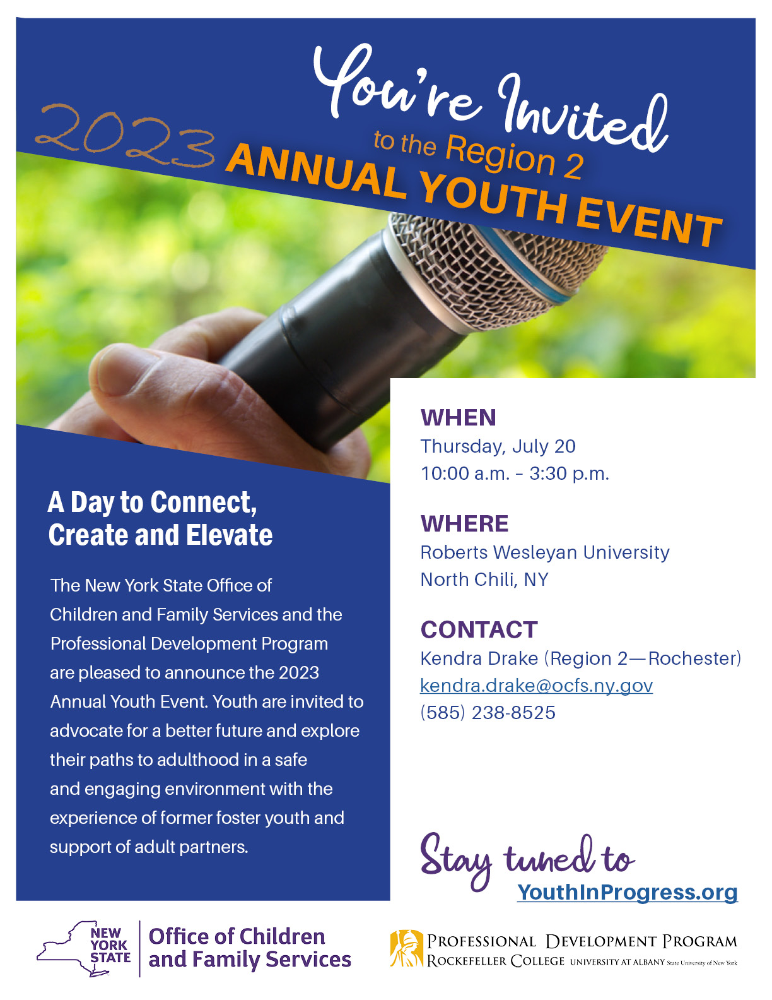

Agenda

THURSDAY, JULY 20, 2023

10:00 a.m. – 10:30 a.m. REGISTRATION / WELCOME

10:30 a.m. – 11:15 a.m. **STRATEGIC SHARING WORKSHOP**

Arts & Crafts, Music & Poetry, Spoken Word

11:20 a.m. – 12:30 p.m. SPEAK OUT

Youth will review Speak Out rules, expectations, and invite youth to share their concerns, issues, suggestions, and success with a panel of policy makers. The intention of the Speak Out is to create meaningful change.

12:30 p.m. –1:30p.m. LUNCH

Great time to network with others!

1:30 p.m. – 2:10 p.m. BREAK OUT ROOM ROTATION

Yellow Group: College Tour

Red Group: Behavioral Health Workshop

Blue Group: Center for Youth Workshop

2:10 p.m. – 2:40 p.m. BREAK OUT ROOM ROTATION

Blue Group: College Tour

Yellow Group: Behavioral Health Workshop

Red Group: Center for Youth Workshop

2:40 p.m. – 3:20 p.m. BREAK OUT ROOM ROTATION

Red Group: College Tour

Blue Group: Behavioral Health Workshop

Yellow Group: Center for Youth Workshop

3:20 p.m. – 3:30 p.m. CLOSING/EVALUATION

Break Out Room Descriptions

Strategic Sharing

This workshop will focus on how to support youth in learning how to find their voice and how their story can help others to understand the experiences that they have been through and shaped their lives through various artistic mediums such as art, poetry and expressive writing. The goal is to support the youth to reframe foster care experiences as expertise and teach the young people how to safely tell their stories while retaining boundaries. Youth will be able to use different methods such as arts, poetry and music.

College Tour

Tour of Roberts Wesleyan University

Behavioral Health Workshop

University of Rochester presents a workshop on Mental and Behavioral Health. This workshop will help youth identify helpful services and resources that could benefit them in their overall mental health and well-being.

Center for Youth Workshop

Housing is something many youth and young adults struggle with. This workshop centers around the Center for Youth program, and all the different housing opportunities their program has to offer including long term and short-term options.

Panelists

**Mindy Banfield**Director of Children and Family Services,   
Chemung County

**Tracy VanVleck**Commissioner, Seneca County

**Teresa Stever**Deputy Commissioner, Steuben County

**Brian Parchesky**President/CEO of Berkshire Farms and Services for Youth

**Natasha Burdick**

AFC, Legal Aid Society

Resource Tables

* Center for Youth
* Trillium Health
* OCFS Youth Development and Partnerships for Success (YDAPS)
* PFLAG
* Families Together
* Rochester Works
* University of Rochester Behavioral Health
* Planned Parenthood
* Roberts Wesleyan University
* National Youth in Transition Database (NYTD)

**2023 Annual Youth Event, Region 2**

**County/Agency Name:**

**Address:**

**Contact Person: Phone #:**

Please list all attending from your county/agency. One staff member must attend for every 4 youth participating.

**County/Agency Staff:**

**Staff Email:**

**Staff Phone/Cell:**

**Youth Names:**

1)

2)

3)

4)

**County/Agency Staff:**

**Staff Email:**

**Staff Phone/Cell:**

**Youth Names:**

1)

2)

3)

4)

**If you have any questions, contact:**  
**Kendra Drake**

Youth Engagement Specialist (YES)

[Kendra.Drake@ocfs.ny.gov](mailto:Kendra.Drake@ocfs.ny.gov)

585-238-8525

**County/Agency Staff:**

**Staff Email:**

**Staff Phone/Cell:**

**Youth Names:**

1)

2)

3)

4)

**County/Agency Staff:**

**Staff Email:**

**Staff Phone/Cell:**

**Youth Names:**

1)

2)

3)

4)

**If you have cancellations, contact:**  
Kendra Drake by **July 13, 2023**

**Please return completed forms to:**

[Kendra.Drake@ocfs.ny.gov](mailto:Kendra.Drake@ocfs.ny.gov)