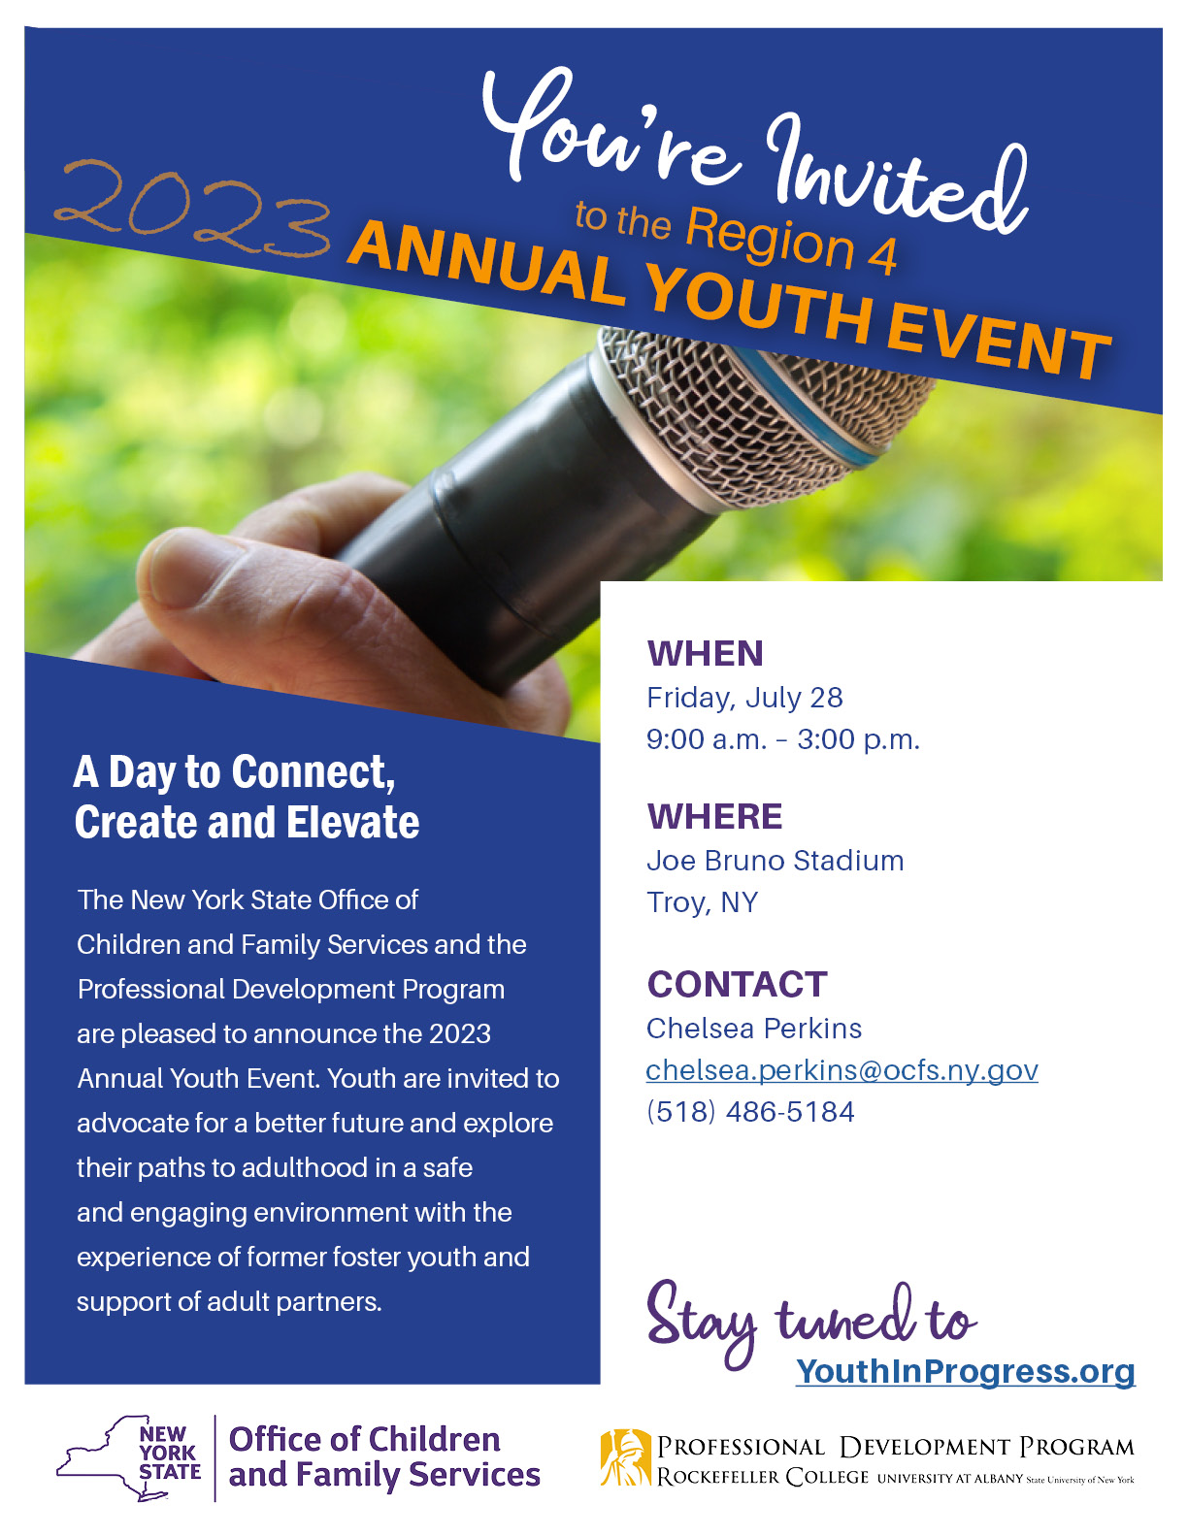

Agenda

FRIDAY, JULY 28, 2023

9:00 a.m. – 10:30 a.m. REGISTRATION / OPTIONAL ON-FIELD BATTING PRACTICE

10:30 a.m. – 10:45 a.m. WELCOME

10:45 a.m. – 11:10 a.m. BREAKOUT ROOM ROTATION

Red Group: Connect Station (Resource Tables)

Blue Group: Create Station (Self-expression through art)

Yellow Group: Elevate Station (Speak out prep)

11:15 a.m. – 11:40 a.m. BREAKOUT ROOM ROTATION

Yellow Group: Connect Station (Resource Tables)

Red Group: Create Station (Self-expression through art)

Blue Group: Elevate Station (Speak Out prep)

11:45 a.m. – 12:10 p.m. BREAKOUT ROOM ROTATION

Blue Group: Connect Station (Resource Tables)

Yellow Group: Create Station (Self-expression through art)

Red Group: Elevate Station (Speak out prep)

12:15 p.m. – 1:15 p.m. LUNCH/OPTIONAL TOURS

Great time to network with others!

1:15 pm – 1:30 pm SPEAK OUT INTRODUCTION

1:30 pm – 2:45 pm SPEAK OUT

Youth will review Speak Out rules, expectations, and invite youth to share their concerns, issues, suggestions, and success with a panel of policy makers. The intention of the Speak Out is to create meaningful change.

2:45 pm – 3:00 pm CLOSING/EVALUATION

Break Out Room Descriptions

Connect (Resource tables)

This workshop is focused on connecting youth to their community. The goal of this workshop is to increase awareness of opportunities and services available to youth within their community. There will be approximately 10 resource tables for youth to visit and learn more about. Youth will be given a “passport” handout that lists each of the resource tables. Once a youth has visited a table, they will receive a sticker that will be placed on the passport to indicate it has been visited. Once the passport is completed, participants will receive a participation gift for completing their passport. Once all of the resource tables have been visited, participants are encouraged to connect with each other at any of the activities around the stadium (connect four, can jam, corn hole, etc.).

Create (Self-expression through art)

Art gives us a way to take a thought in our heads and put it onto a page or into a drawing, painting, or performance. It thereby releases the emotions around that thought and gives others the opportunity to comprehend it. This workshop will provide a place for participants to create art that can be used during their speak out. Sometimes it’s hard to find the right words to say to a large group of people and it may be easier to express it through art. This workshop will include an activity to get participants into a creative mindset and then will provide time for participants to express themselves at the art stations.

Elevate (Speak Out prep)

By definition, elevate is to move or raise to a higher place or position, and this is exactly what this breakout group is all about - elevating youth to the next level by giving them the time and space to brainstorm their speak out speeches so that they can confidently present to the panelists. During this workshop, we will be hearing from the youth directly about their thoughts, feelings, and experiences. Our workshop leader will facilitate conversation to elevate the youth’s thoughts and feelings into how we can elicit change given these experiences.

Panelists

**Joyce Charland**  
Foster Parent

**Jennifer Depew (Ganey)**Director of Children and Family Services, Columbia County Department of Social Services

**John Kraigenow**  
Director of the Office of Attorneys for Children

**Michelle Parady**  
Chief Program Officer at St. Anne’s Institute

**Lynn Tubbs**  
Director, Bureau of Cross System Supports, Division of Youth Development and Partnerships for Success (OCFS)

Resource Tables

* Job Corp
* Pride Center
* Department of Health
* SEFCU Bank
* Unity House (Domestic Violence) Awareness
* ETV & Higher Education
* OCFS Youth Development and Partnerships for Success (YDAPS)
* National Youth in Transition Database (NYTD)

**2023 Annual Youth Event, Region 4**

**County/Agency Name:**

**Address:**

**Contact Person: Phone #:**

Please list all attending from your county/agency. One staff member must attend for every 4 youth participating.

**County/Agency Staff:**

**Staff Email:**

**Staff Phone/Cell:**

**Youth Names:**

1)

2)

3)

4)

**County/Agency Staff:**

**Staff Email:**

**Staff Phone/Cell:**

**Youth Names:**

1)

2)

3)

4)

**If you have any questions, contact:**  
**Chelsea Perkins**

Youth Engagement Specialist (YES)

<mailto:Chelsea.Perkins@ocfs.ny.gov>

(518) 486-5184

  
**County/Agency Staff:**

**Staff Email:**

**Staff Phone/Cell:**

**Youth Names:**

1)

2)

3)

4)

**County/Agency Staff:**

**Staff Email:**

**Staff Phone/Cell:**

**Youth Names:**

1)

2)

3)

4)

**If you have cancellations, contact:**  
Chelsea Perkins by **July 21, 2023.**

**Please return completed forms to:**

[Chelsea.Perkins@ocfs.ny.gov](mailto:Chelsea.Perkins@ocfs.ny.gov)