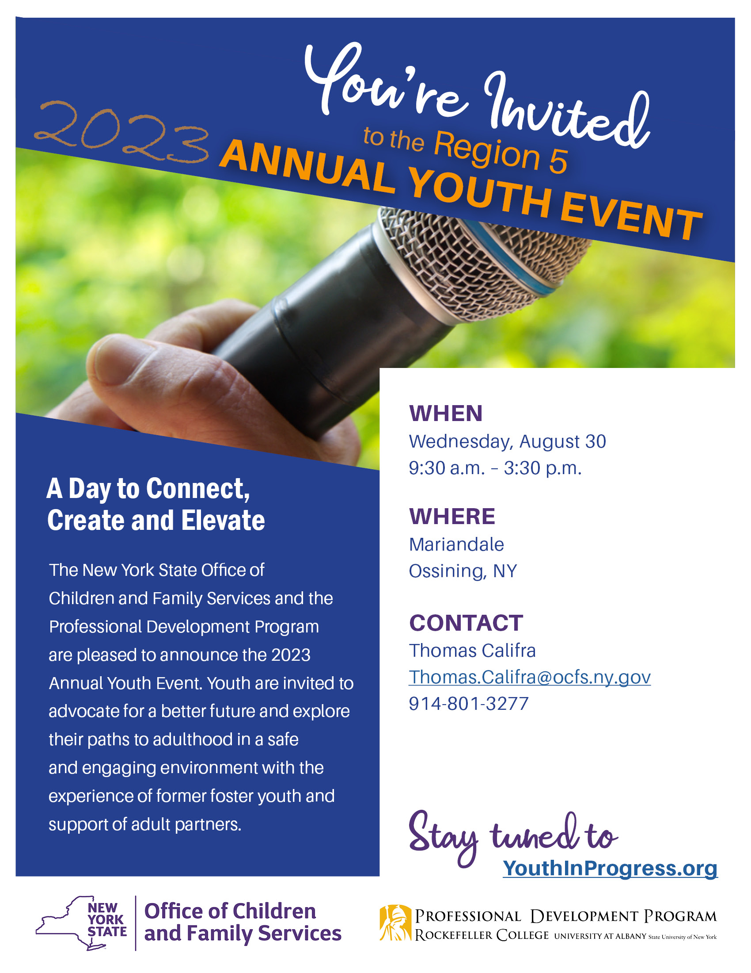

Agenda

WEDNESDAY, AUGUST 30, 2023

9:30 a.m. – 10:30 a.m. REGISTRATION & RESOURCE TABLES

10:30 a.m. – 11:00 a.m. WELCOME & KEYNOTE SPEAKER

11:00 a.m. – 11:30 a.m. BREAKOUT ROOM ROTATION

Red Group: Dance Expression

Blue Group: Mindfulness and Writing

Yellow Group: Public Speaking 101

11:30 a.m. – 12:00 p.m. BREAKOUT ROOM ROTATION

Yellow Group: Dance Expression

Red Group: Mindfulness and Writing

Blue Group: Public Speaking 101

12:00 p.m. – 12:30 p.m. BREAKOUT ROOM ROTATION

Blue Group: Dance Expression

Yellow Group: Mindfulness and Writing

Red Group: Public Speaking 101

12:30 p.m. – 1:30 p.m. LUNCH & NETWORKING

Great time to network with others!

1:30 p.m. – 1:45 p.m. SPEAK OUT INTRODUCTION

1:45 p.m. – 3:00 p.m. SPEAK OUT

Youth will review Speak Out rules, expectations, and invite youth to share their concerns, issues, suggestions, and success with a panel of policy makers. The intention of the Speak Out is to create meaningful change.

3:00 p.m. – 3:30 p.m. CLOSING/EVALUATION

Break Out Room Descriptions

The Theme of this year’s speak out is *Connect, Create, and Elevate*.

**Dance Expression:** Youth will create expressive dance movements to learn new ways of expression.

**Mindfulness and Writing:** Youth will have the opportunity to participate in mindfulness activities that will help them connect with their inner thoughts and feelings.

**Public Speaking:** Youth will have the opportunity to elevate their skills in public speaking through this helpful workshop.

**2023 Annual Youth Event, Region 5**

**County/Agency Name:**

**Address:**

**Contact Person: Phone #:**

Please list all attending from your county/agency. One staff member must attend for every 4 youth participating.

**County/Agency Staff:**

**Staff Email:**

**Staff Phone/Cell:**

**Youth Names:**

1)

2)

3)

4)

**County/Agency Staff:**

**Staff Email:**

**Staff Phone/Cell:**

**Youth Names:**

1)

2)

3)

4)

**If you have any questions, contact:**  
**Thomas Califra**

Youth Engagement Specialist (YES)

Thomas.Califra@ocfs.ny.gov   
(914) 801-3277

  
**County/Agency Staff:**

**Staff Email:**

**Staff Phone/Cell:**

**Youth Names:**

1)

2)

3)

4)

**County/Agency Staff:**

**Staff Email:**

**Staff Phone/Cell:**

**Youth Names:**

1)

2)

3)

4)

**If you have cancellations, contact:**  
Thomas Califra by **August 23, 2023.**

**Please return completed forms to:**

PDP-YST@albany.edu